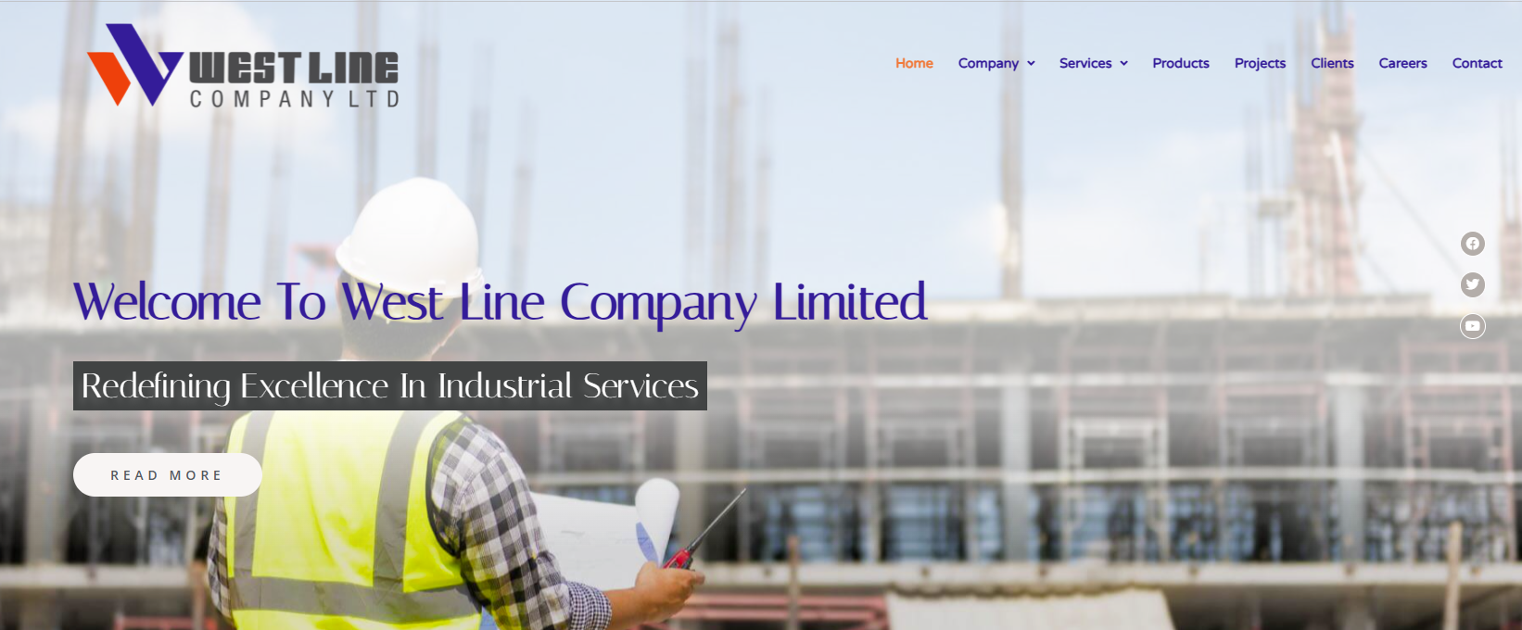
Logo insert in yellow section
Add more live images. Now only two.

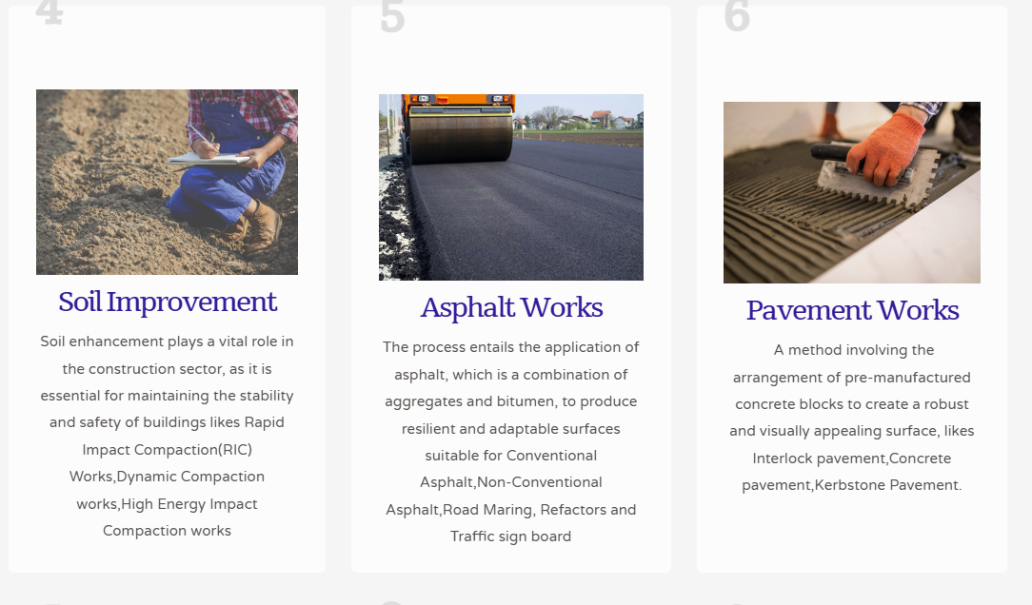
Soil Improvement Works
Soil improvement enhances ground stability and load-bearing capacity in construction. Techniques like Rapid Impact Compaction(RIC), Dynamic Compaction(DC), and High-Energy Impact Compaction(HEIC) densify weak soils using controlled energy, reducing voids and strengthening foundations. This prevents failures, ensures integrity, and cuts costs, with methods chosen based on soil type and project needs
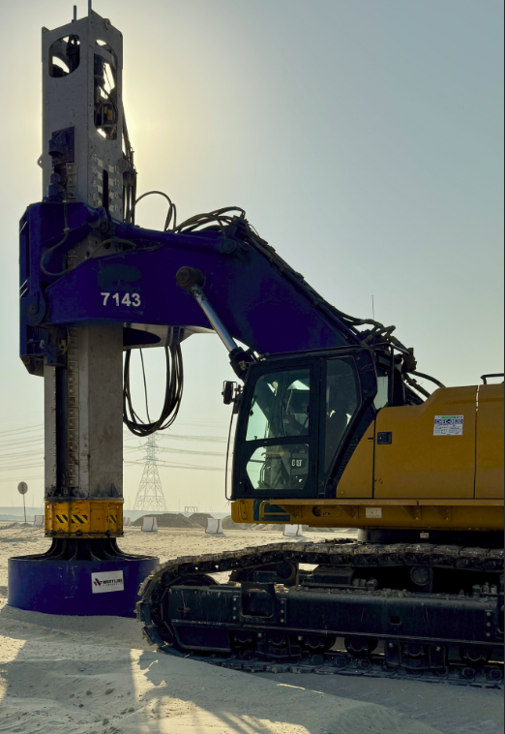 Reference Image 1

Asphalt Works
Asphalt pavement involves laying a durable, versatile mixture of aggregates and bitumen, creating surfaces ideal for various applications. This process produces robust solutions for conventional and non-conventional asphalt, road markings, reflectors, and traffic signboards, ensuring long-lasting performance and adaptability to diverse infrastructure needs.
Pavement Works
This technique utilizes pre-cast concrete blocks to craft a strong, attractive surface for applications such as interlocking pavement, concrete pavement, and Kerbstone pavement. The method ensures durability and aesthetic appeal while providing a reliable foundation for diverse paving needs
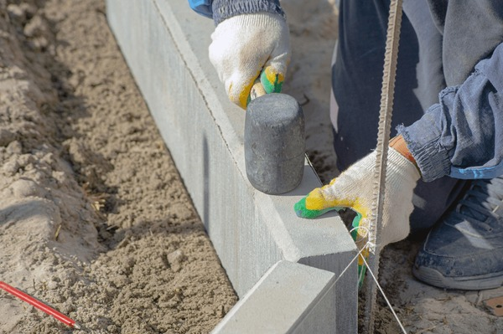 Ref : 2

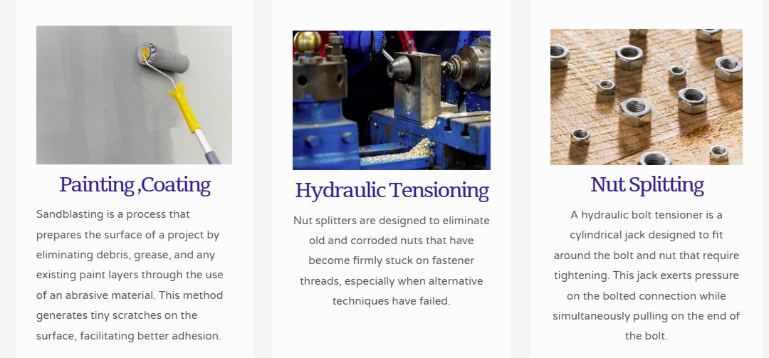
Painting and Coating
Sand blasting and coating works in industrial settings involve the use of high-pressure abrasive blasting followed by protective coatings to enhance durability and corrosion resistance. This process prepares and treats surfaces for applications like machinery, pipelines, and structural steel, ensuring long-term performance and resilience in demanding environments.
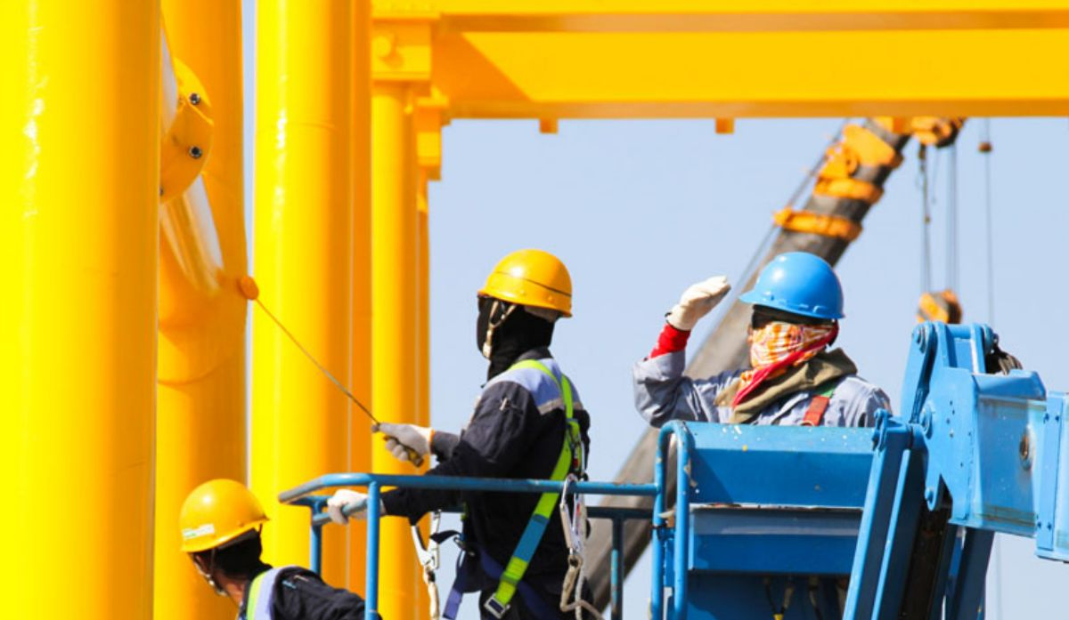 Ref : 3
Hydraulic Bolt torquing and Tensioning
Hydraulic bolt torquing and tensioning utilize hydraulic tools to apply controlled force to bolts, ensuring precise and uniform fastening. This method strengthens connections for applications like industrial equipment, pipelines, and structural assemblies, delivering exceptional reliability and load-bearing capacity in high-pressure, heavy-duty environments.
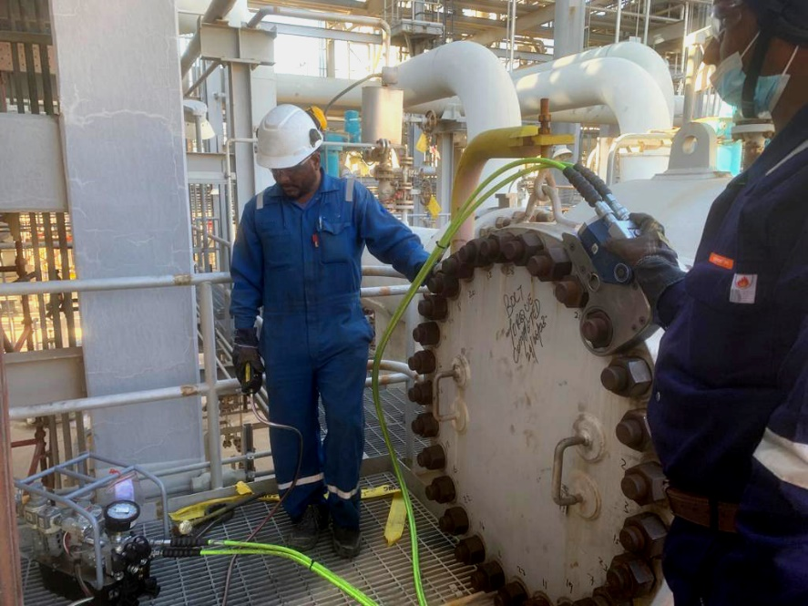 Ref 4

Hydraulic Nut splitting
Hydraulic nut splitting employs powerful hydraulic tools to cut through seized or damaged nuts, facilitating safe and efficient removal. This technique is ideal for industrial maintenance, heavy machinery, and structural repairs, offering a precise, damage-free solution for disassembling components in challenging, high-stress settings.
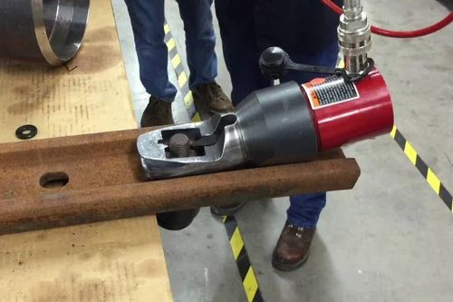 Ref: 5

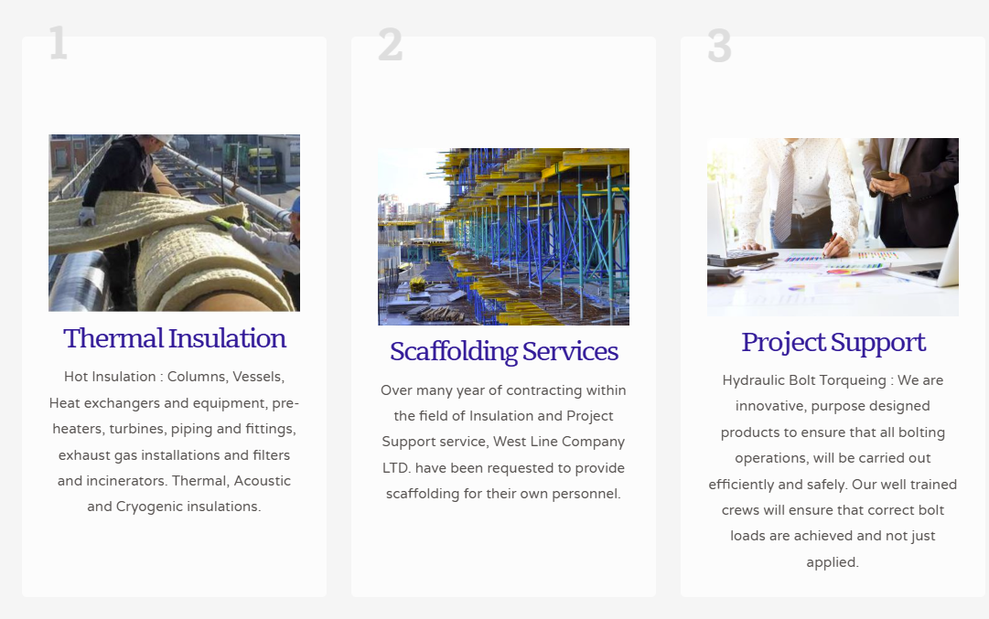

Project Support Service shall replace with “Bolt Torquing and Tensioning Service”

Where Hydraulic Tensioning mention please Replace with Project Support Service
Short Brief :
Project support services provide essential resources to ensure the smooth execution of industrial and construction projects. This includes supplying specialized manpower, renting high-quality equipment, providing scaffolding materials, and delivering tailored material supplies. These services enhance operational efficiency, ensure safety, and support project timelines, making them ideal for complex, large-scale projects in demanding environments.
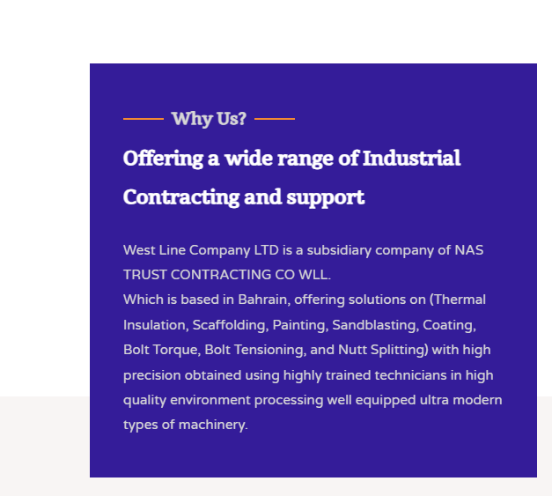

Why Us?
“Offering a wide range of Industrial Contracting and support”
West Line Company Ltd, based in Jubail, Saudi Arabia, and a subsidiary of NAS Trust Contracting Co WLL from Bahrain, is your premier partner for a wide range of specialized services. With expertise in thermal insulation, scaffolding, painting, sandblasting, coating, hydraulic bolt torque and tensioning, nut splitting, soil improvement, asphalt construction, pavement works, and project support, we deliver tailored, high-quality solutions to meet your industrial and construction needs. Strategically located in the Eastern Province, we combine local insight with international standards, ensuring precision, safety, and efficiency in every project—making us the trusted choice for businesses seeking reliable, end-to-end support.
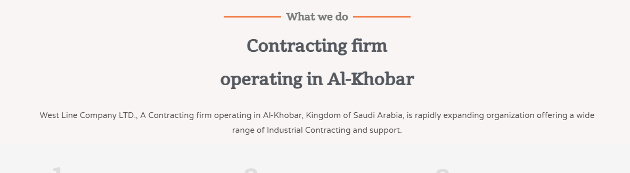

What we do
“Redefining Excellence in Industrial Services”
No Need : “Contracting firm operating in Al-Khobar” and the rest of sentences.

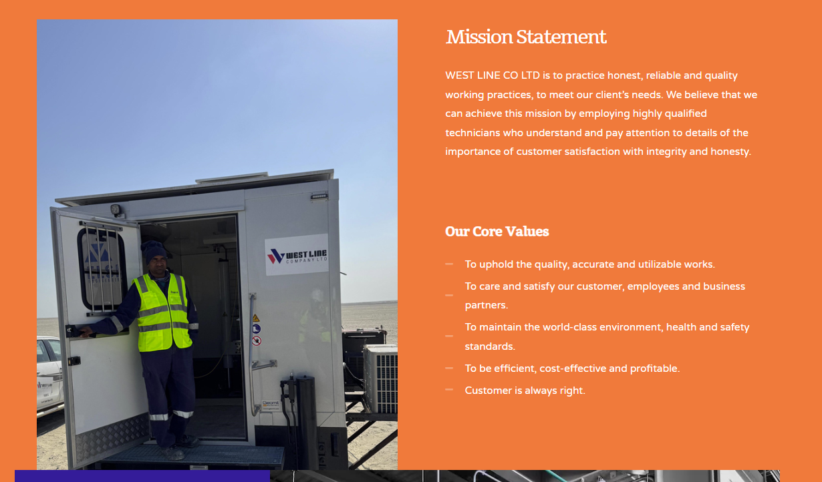
Image shall replace

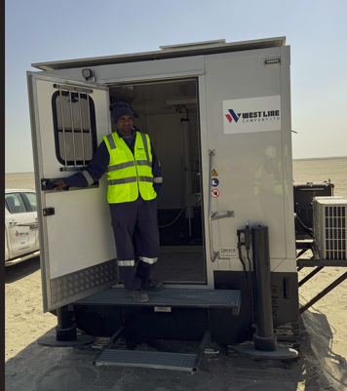 REF Image 6
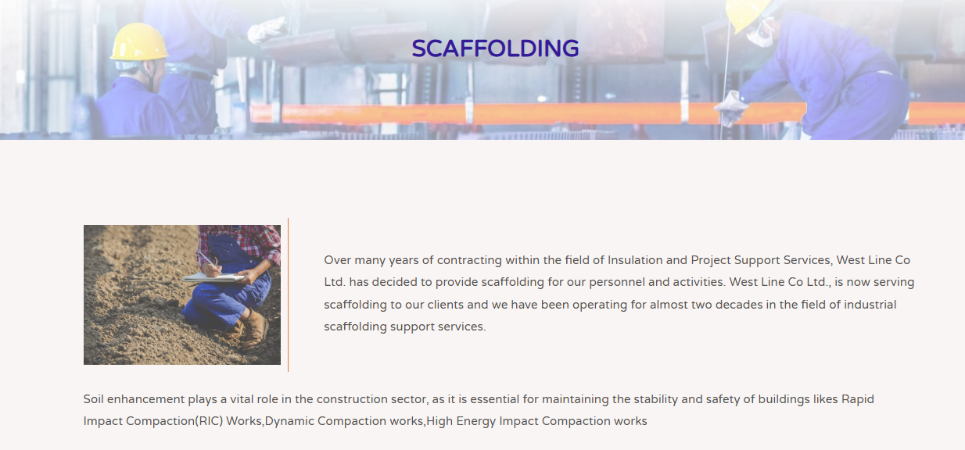
West Line Company Ltd offers top-tier scaffolding services backed by decades of experience in the industry. Based in Jubail, Saudi Arabia, we provide safe, reliable, and efficient scaffolding solutions tailored to meet the unique demands of every project, from small-scale construction to large industrial undertakings. Our seasoned team leverages advanced techniques and equipment to ensure secure access and structural support, delivering exceptional quality and peace of mind to clients across the Eastern Province and beyond.
**Image needed to change
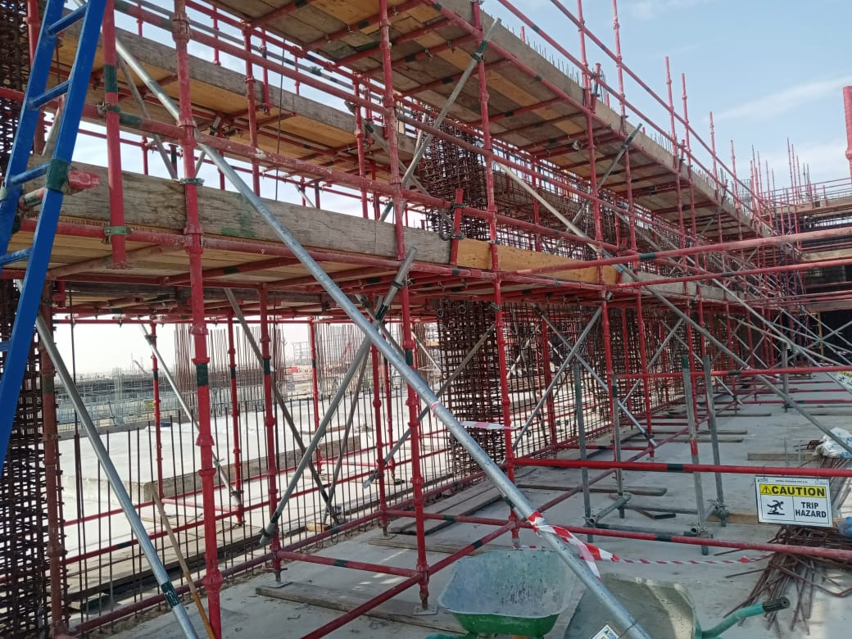 REF Image : 7

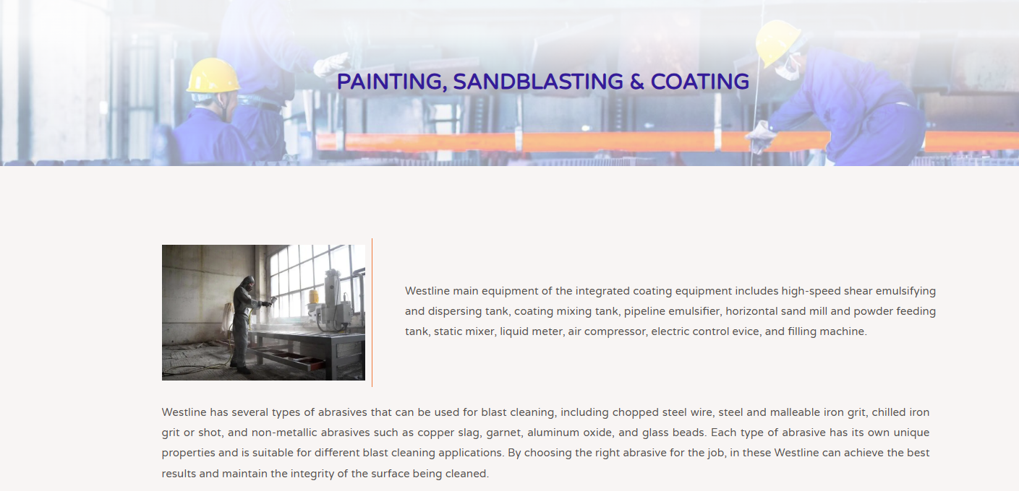

West Line Company Ltd delivers expert painting, sandblasting, and coating services, supported by decades of experience in the field. Operating from Jubail, Saudi Arabia, we provide durable, high-quality finishes that protect and enhance your assets, tailored to the specific needs of each project—whether industrial, commercial, or infrastructural. Our skilled team employs cutting-edge techniques and premium materials to ensure long-lasting results, making us a trusted choice for clients throughout the Eastern Province and beyond.

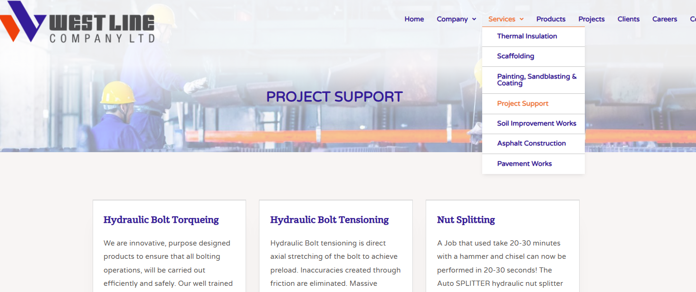

Drop down menu “ Project Support “ need to change Hydraulic Bolt Torquing, Tensioning and Nut Splitting Service

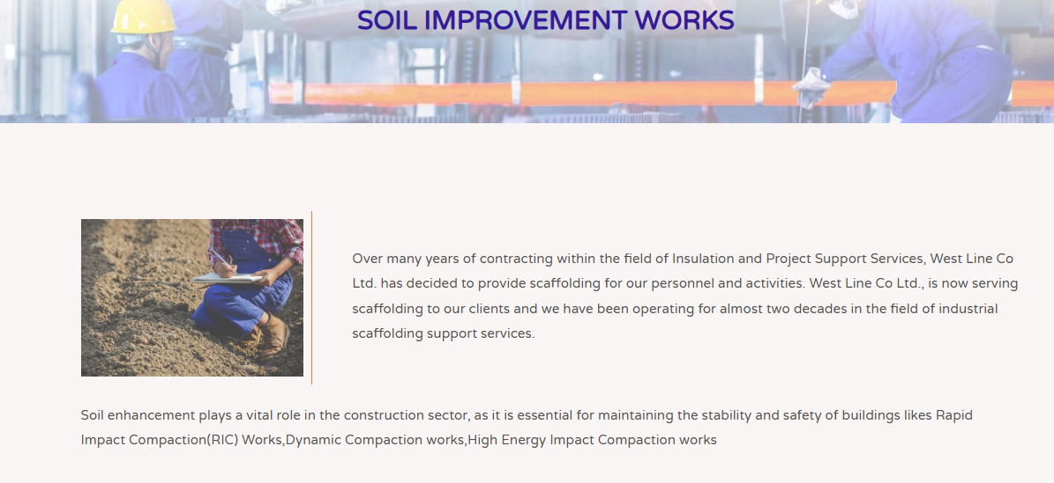
Brief :
West Line Company Ltd excels in soil improvement works, leveraging years of experience to enhance foundations for enduring stability. We employ advanced techniques like Rapid Impact Compaction (RIC), Dynamic Compaction (DC), and High-Energy Impact Compaction (HIEC) to optimize soil conditions, customized to meet the specific needs of each project—whether industrial, infrastructure, or construction. Our skilled team delivers consistent, high-quality results, establishing us as a trusted partner for clients throughout the Eastern Province and beyond.
Image : Referral Images needs to change as well

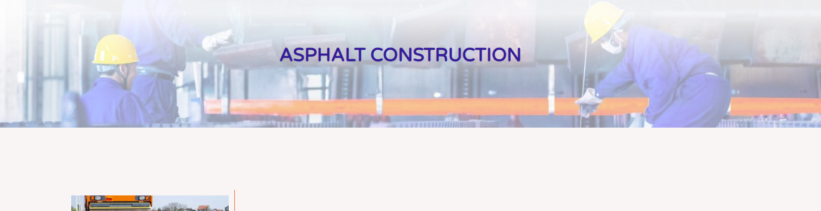
Asphalt works are an essential part of West Line’s offerings, backed by years of experience in delivering robust and reliable surfacing solutions. We provide both conventional and non-conventional asphalt techniques, customized for road pavements across commercial developments, industrial plants, and residential communities. Our skilled team focuses on quality craftsmanship and enduring results, ensuring we meet the diverse needs of clients throughout the Eastern Province and beyond.
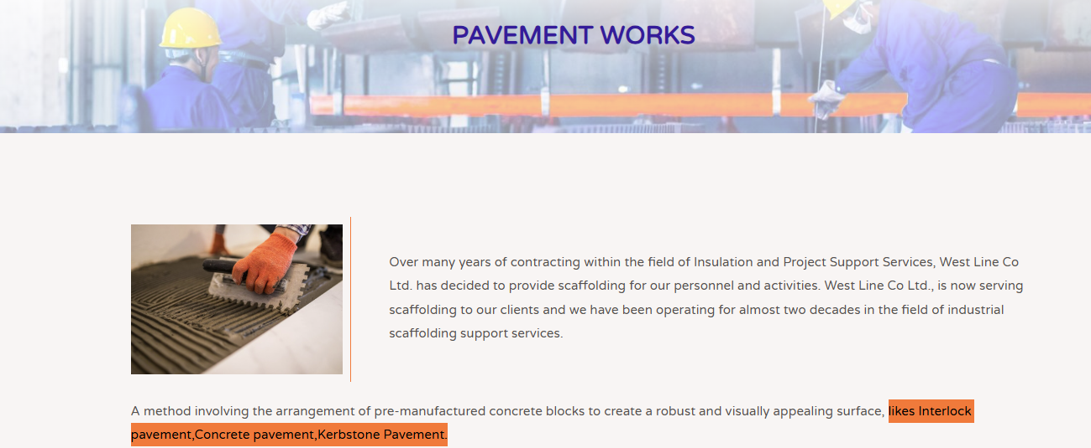

Pavement works are a service offered by West Line Company Ltd., backed by extensive experience in delivering durable and high-performance surfaces. We specialize in a variety of solutions such as walkway pavements, interlock pavements, concrete pavements, and kerbstone pavements—each tailored to suit the needs of commercial, industrial, and residential projects. Our experienced team ensures accurate execution and long-lasting quality, making West Line a trusted partner for pavement solutions across the Eastern Province and beyond.
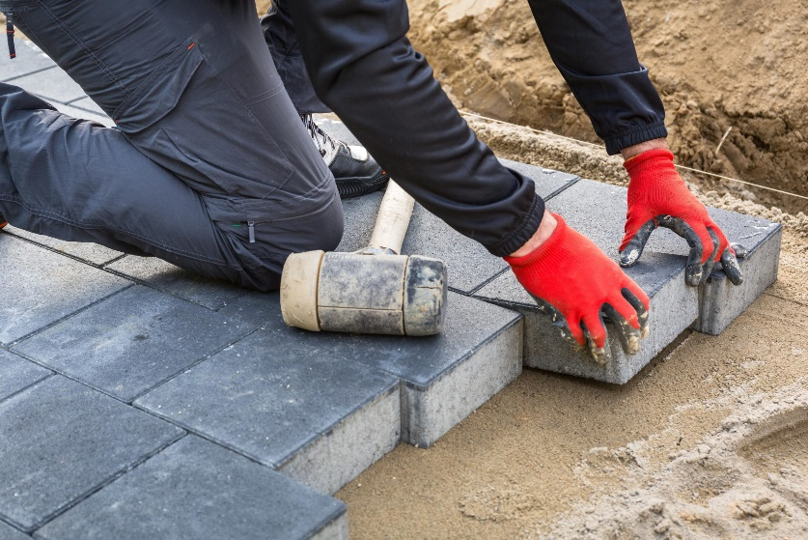 Ref : 8

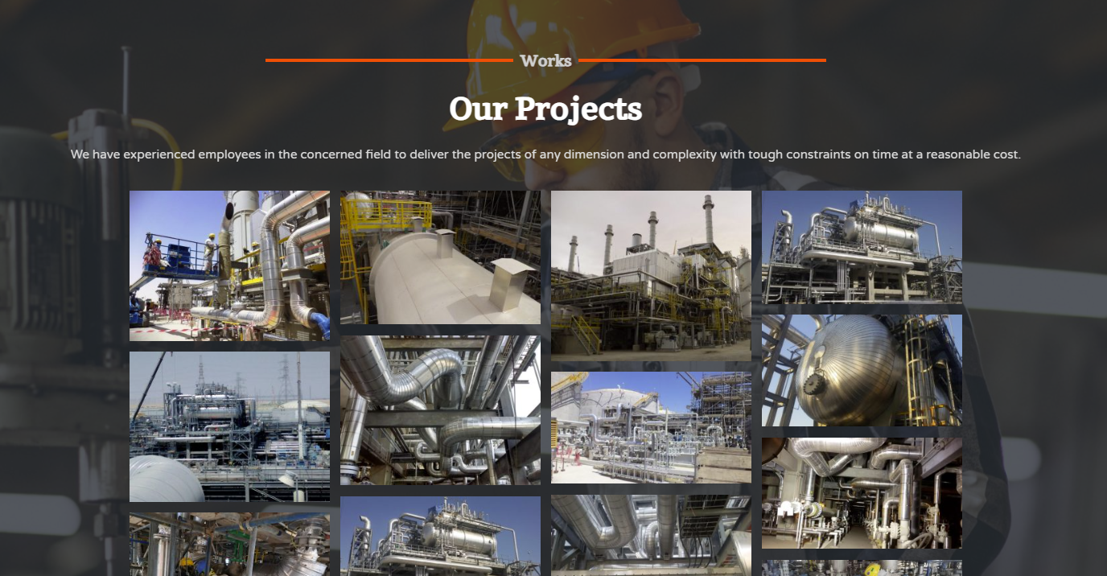
Add more images from scaffolding, torquing, soil improvement, asphalting, etc.

CEO Message
Dear Valued Clients, Partners, and Team Members,
It is with immense pride that I address you as the CEO of West Line Company Ltd., a trusted leader in delivering specialized industrial and construction services. We are dedicated to providing a wide range of high-quality services, including Thermal Insulation, Scaffolding Services, Painting, Sandblasting and Coating, Hydraulic Bolt Torquing, Nut Splitting, Project Support Services, Hydraulic Bolt Tensioning, Soil Improvement Works, Asphalt Construction, and Pavement Works. Our goal is to support our clients in achieving project success by delivering exceptional solutions tailored to their needs, all while maintaining the highest standards of safety, quality, and efficiency.
At West Line, our strength lies in our highly skilled team, who bring expertise, innovation, and a commitment to excellence to every project. We continuously invest in training and development to ensure our workforce remains at the forefront of industry best practices. Fostering local talent development is a core priority, as we aim to contribute positively to the communities we serve.
Our team leverages cutting-edge technologies and a collaborative approach to deliver projects on time and within budget. We uphold the values of professionalism, integrity, and transparency in all our interactions with clients, vendors, and partners, ensuring that every project is executed with precision and care. From providing safe scaffolding solutions to executing complex hydraulic bolt tensioning and soil improvement works, we are equipped to handle the most demanding challenges with a focus on detail and reliability.
West Line Company Ltd. has established a strong presence across the region, serving industries such as oil and gas, infrastructure, and construction. Our diversified portfolio allows us to support a wide range of projects, from specialized thermal insulation and Scaffolding Service to Torquing service, asphalt construction and pavement works.
With years of experience, my team and I are committed to delivering safe, timely, and cost-effective solutions that meet your project goals. Our dedication to exceeding client expectations has earned us a reputation for reliability, resulting in long-term partnerships and repeat business opportunities.
On behalf of West Line Company Ltd., I assure you of our unwavering commitment to surpassing your expectations and delivering outstanding results on every project we undertake.
Warm regards,

Sims Sudhakaran
Chief Executive Officer
West line company Ltd.

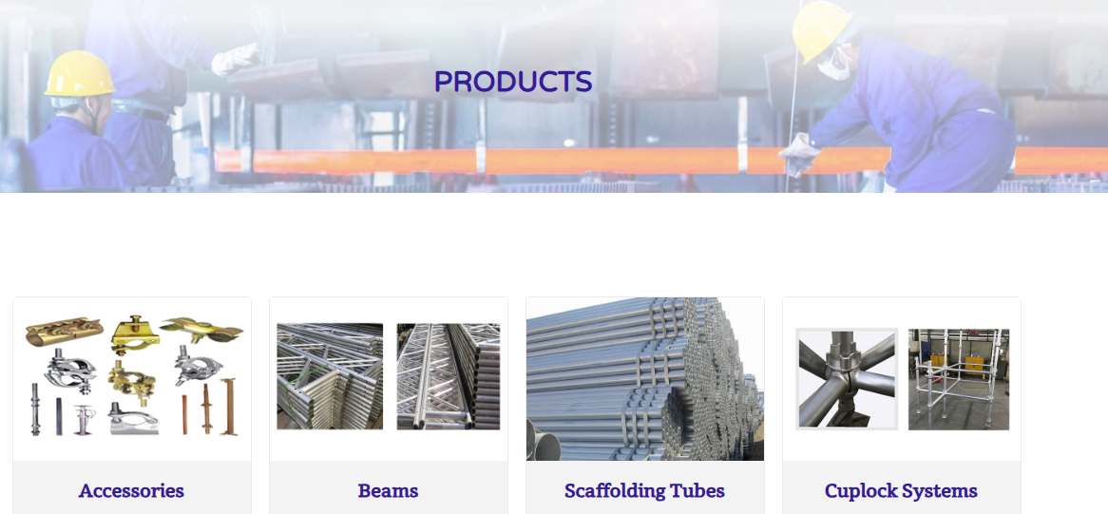
PRODUCTS -> PRODUCTS WE SUPPLY
SL | Project Name | Client | Name of Work Package | Project Country | Finish
1 | Scaffolding & Roofing Sheet Changing Work | Al Mousawi @ Aramco, Dhahran, KSA. | Scaffolding & Roofing | Saudi Arabia | Ongoing  Completed

Replace with latest
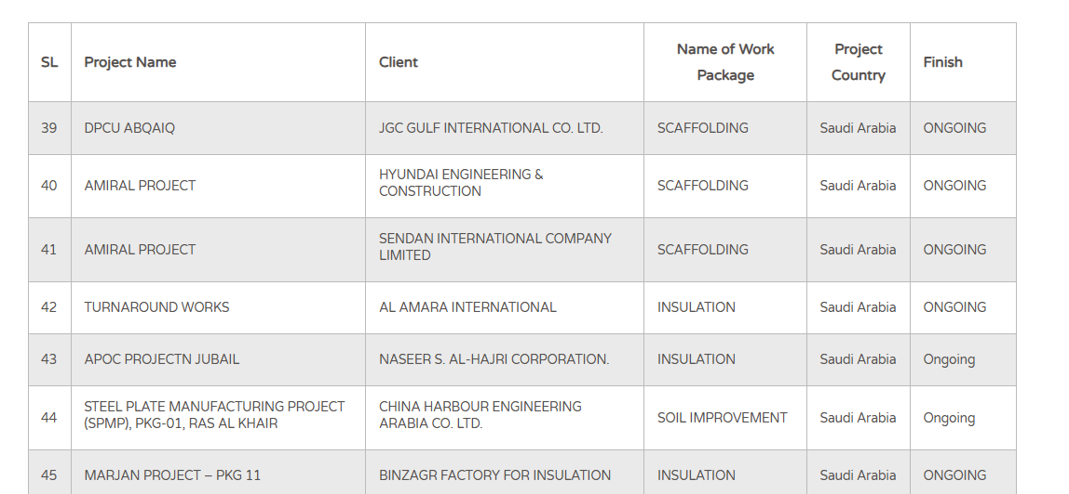
New Ongoing projects shall be comes to the first page

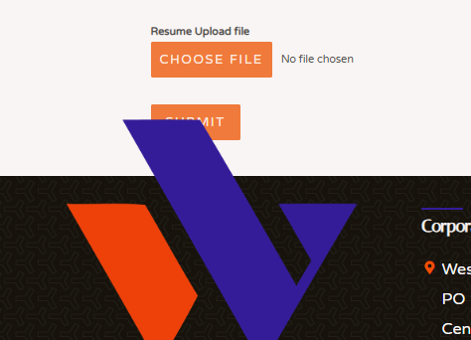
Change the Submit button next to the Choose File Button

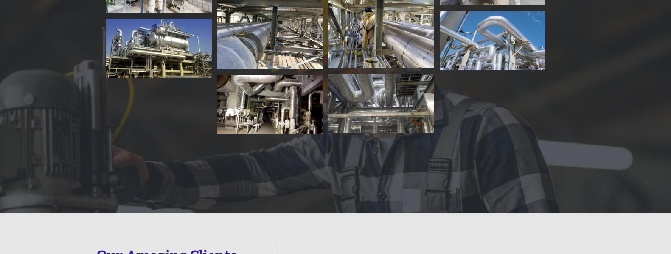

Change all BG images and use images from Project images provided and activity related.

